Smart City Waste CRM - Phase 2

Phase 2 focuses on Org Setup & Configuration. In this phase, we configure company information, users, roles, profiles, permission sets, sharing settings, and named credentials. This document also provides placeholders where you can paste your screenshots as proof of completion.

# Step 1: Company Information

1. Go to Setup → Company Information (Organization Information).  
2. Update the following fields:  
 - Organization Name: Smart City Waste CRM  
 - Primary Contact: Akshitha Morigadi   
 - Country: India  
 - Time Zone: GMT+5:30 India Standard Time  
 - Locale: English (India)  
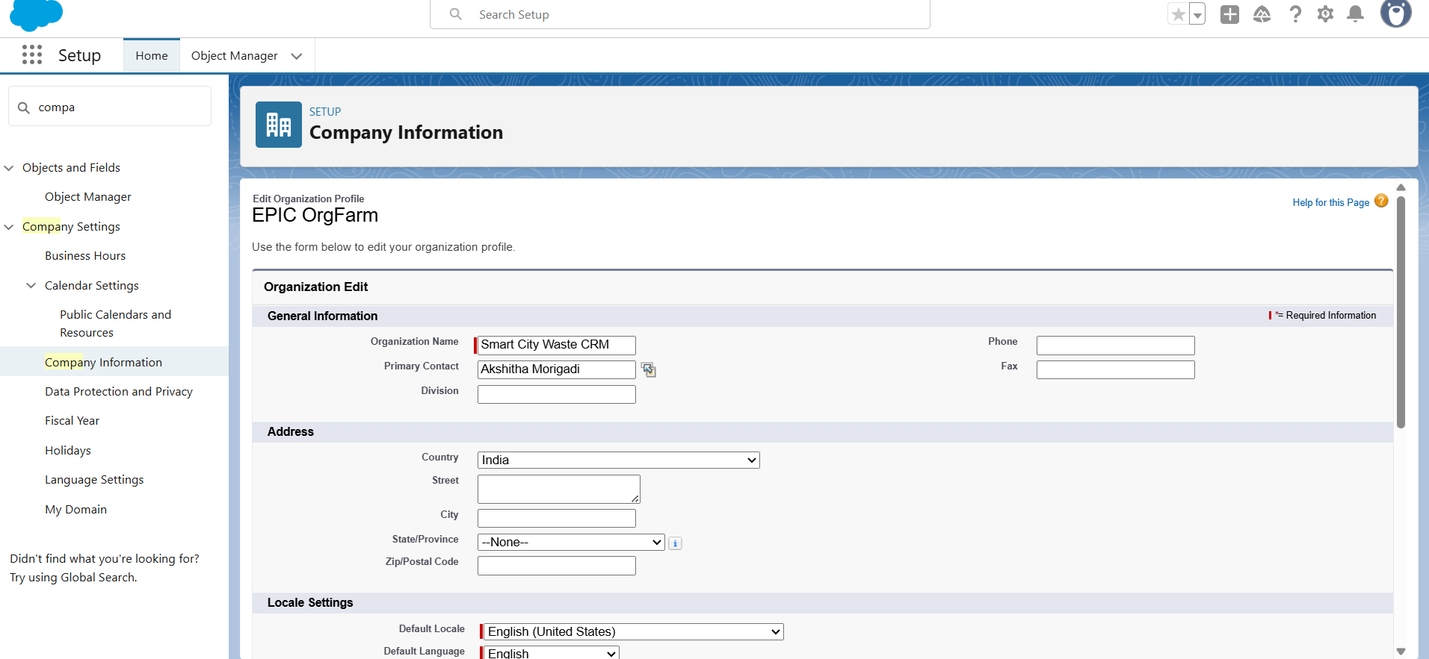

# Step 2: Business Hours & Holidays

1. Go to Setup → Business Hours.  
2. Create new Business Hours: City Waste Collection Hours (Mon–Sat, 9AM–7PM).  
3. Go to Setup and add National Holidays (e.g., Independence Day, Diwali). → Holidays 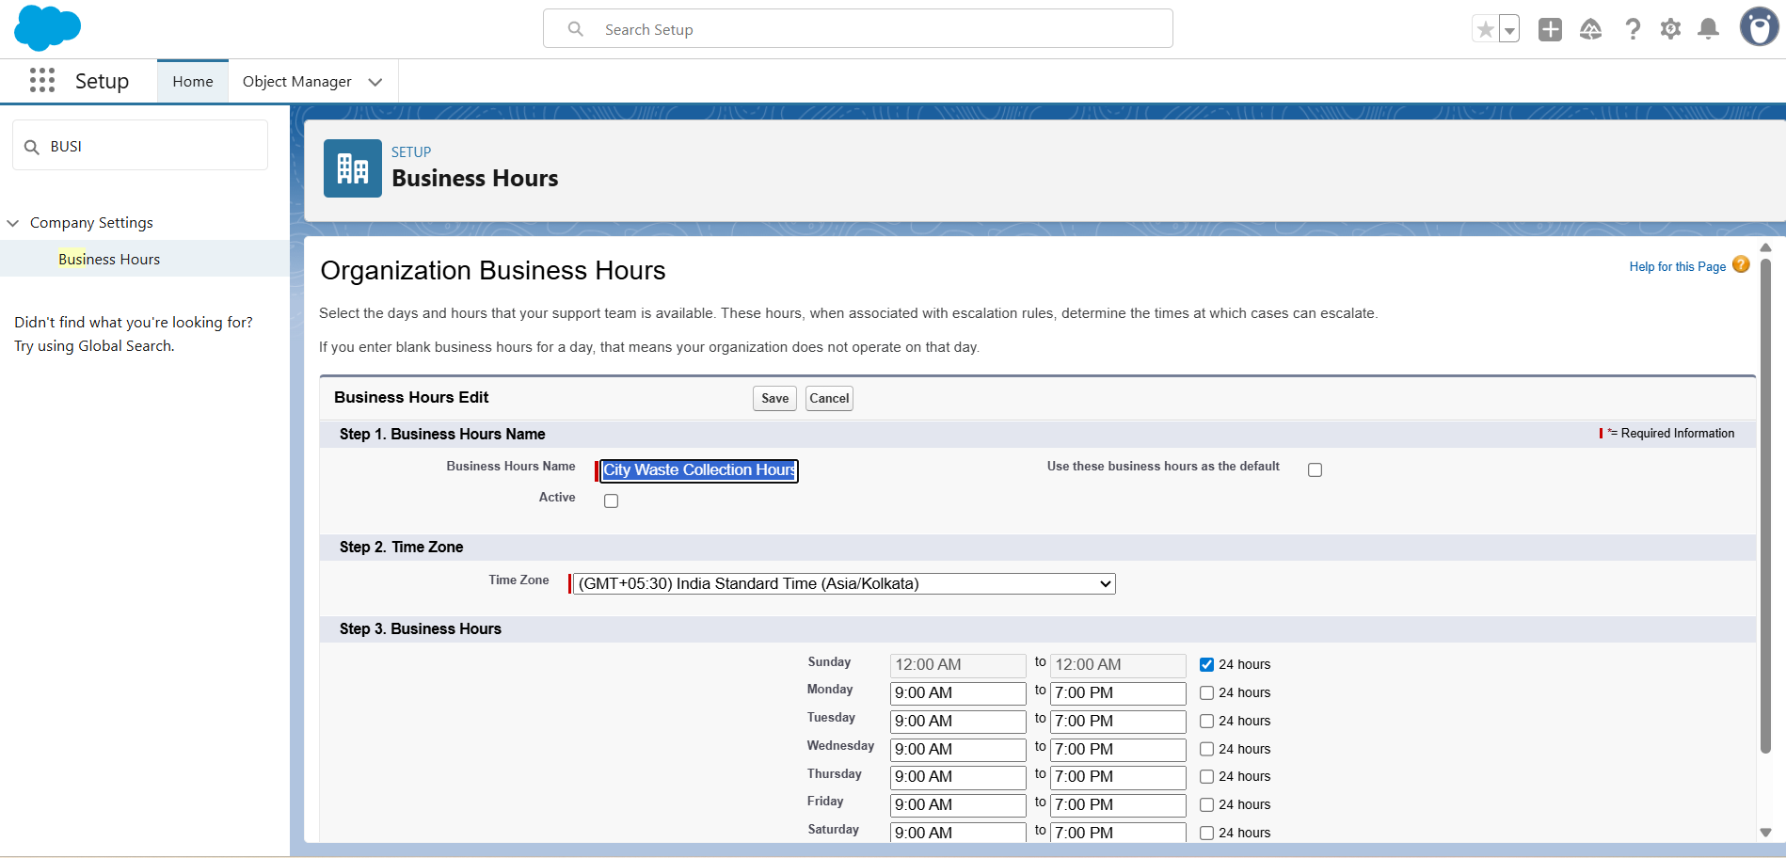

# Step 3: Users

1. Go to Setup → Users → New User.  
2. Create at least 4 users for testing:  
 - Citizen User  
 - Collector User  
 - Plant Admin User  
 - City Official User

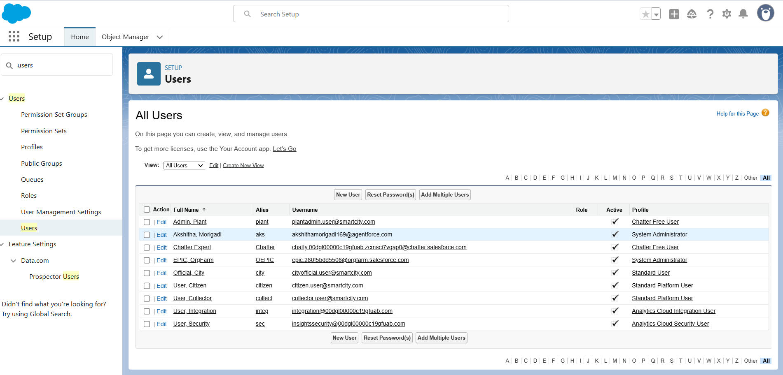

# Step 4: Roles & Role Hierarchy

1. Go to Setup → Roles → Set Up Roles.  
2. Create hierarchy:  
 - City Official (Top)  
 - Plant Admin  
 - Collector -- Citizen  
 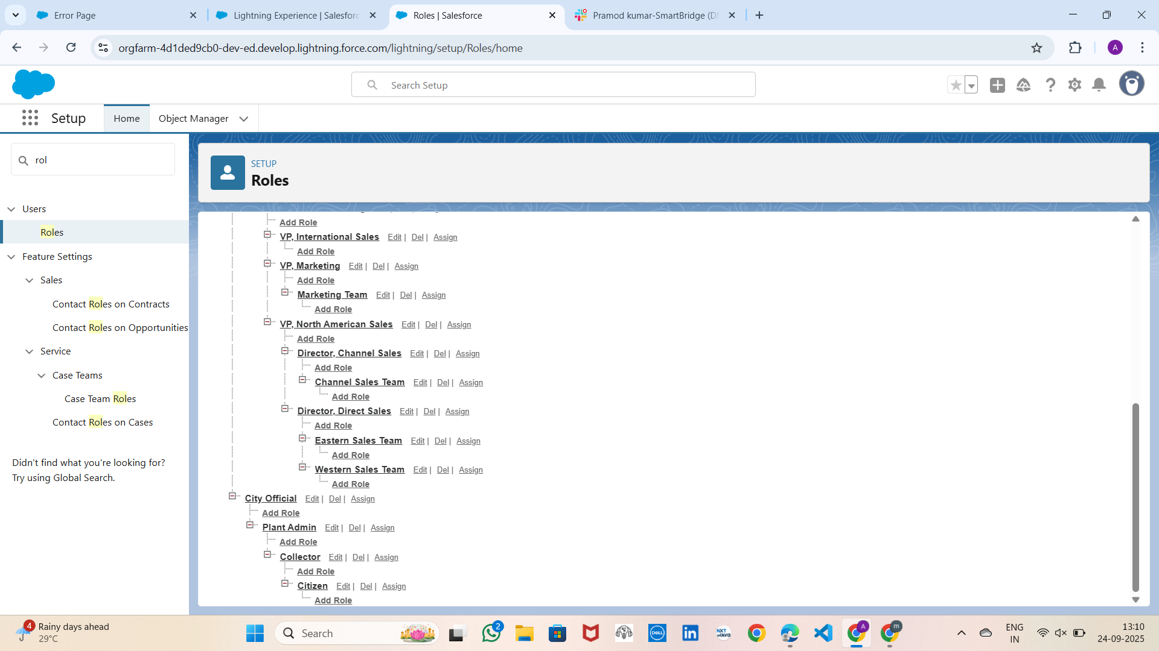

# Step 5: Profiles

1. Go to Setup → Profiles.  
2. Clone Standard User profile into:  
 - Citizen Profile  
 - Collector Profile  
 - Plant Admin Profile  
 - City Official Profile  
3. Set permissions as per Phase 2 instructions.

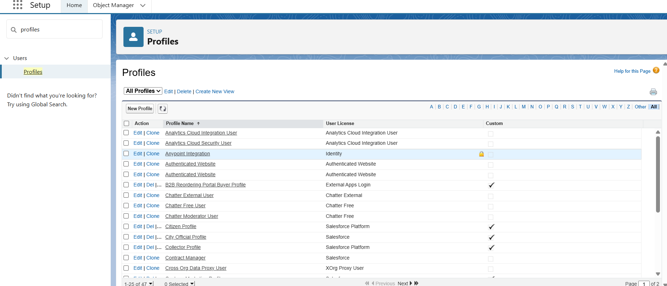

# Step 6: Permission Sets

1. Go to Setup → Permission Sets → New.  
2. Create:  
 - Pickup Request Access (Citizens)  
 - Truck Management Access (Collectors)

# Step 7: Sharing Settings

1. Go to Setup → Sharing Settings.  
2. Set OWD for Pickup_Request__c = Private.  
3. Add Sharing Rules:  
 - City Officials: View/Modify All Requests  
 - Collectors: Can only see Assigned Requests